# Oscilloscopes and Function Generators Worksheet

## Introduction

The focus of this worksheet is to introduce Oscilloscopes and Function Generators as powerful test equipment which help in testing designs under test (DUT).

## Oscilloscopes

### Discussion Overview

In electrical engineering, once a circuit is built, testing the design involves various voltage and current measurements to make sure they match predicted or intended values. Some voltages and currents in a circuit do not change appreciably over time. An example of this is the voltage at a power supply such as a battery. For most parts, as the circuit operates, the voltage across a battery does not change much over time. These kinds of “static” measurements are easily made using a multimeter.

Circuits with voltages and currents that do not change with time, however, are not very terribly interesting. Most circuits that do something interesting have values that change, at times quite rapidly, with time. For such circuits, an oscilloscope is the test equipment of choice. Using an oscilloscope, one can capture the time varying voltage at a node (with respect to ground) as a “real time” waveform. One can observe and measure the change in the voltage over time and determine how fast the voltage is changing.

In the next sections, we will go through step by step procedure on how to properly configure an oscilloscope and make meaningful measurements.

### Procedures

For all the steps below, refer to Figure 1 for the location of configuration knobs, buttons or soft-keys and Figure 2 for the indicators on the Readout Display. Please spend a few moments familiarizing yourself with the configuration/functional groups in Figure 1 and on your oscilloscope.

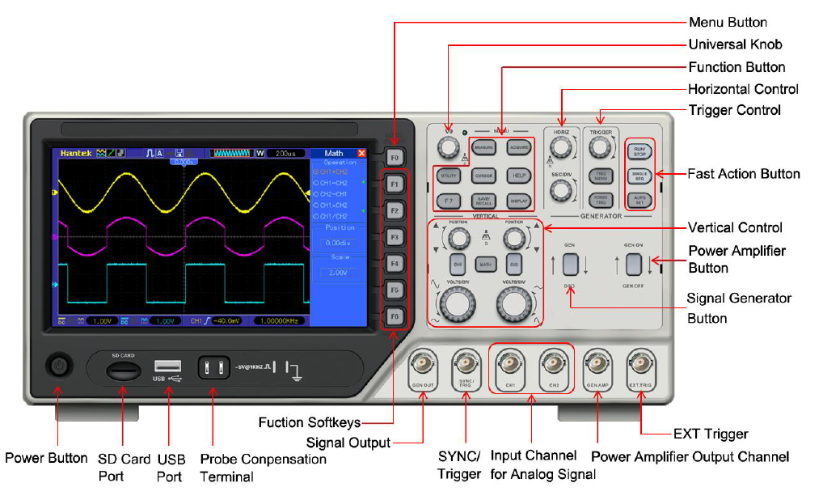

Figure 1 - Hantek DSO4102C Oscilloscope

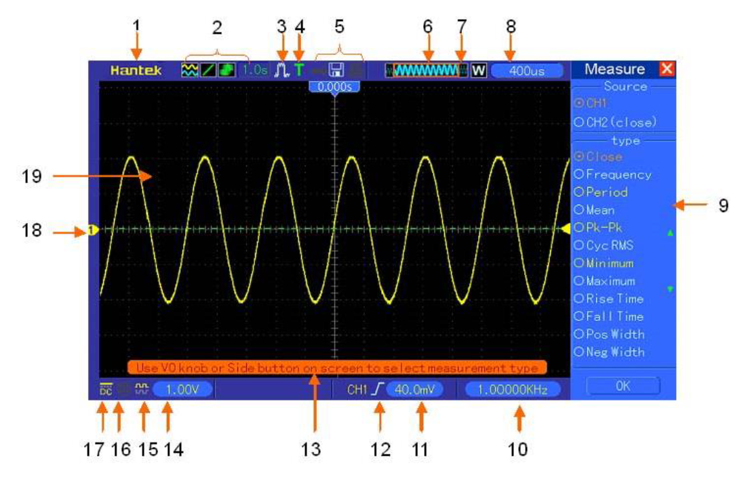

Figure 2 - Oscilloscope's Readout Display

Basic Setup

1. Connect your oscilloscope to the wall power and turn it on by pressing the power button.
2. Once the oscilloscope has gone through self-configuration, enable channel one only by pressing the “CH1” button in the “Vertical Control” group (See Figure 1).
   1. Make sure that only “CH1” button is lit up. If “CH2” is lit up, turn it off by pressing it once.
   2. The buttons in the “Generator” group should also be turned off.
3. Connect one probe to the channel 1 analog input by inserting and then twisting the probe’s BNC connector onto “CH1” BNC connector on the scope in. (“CH1” BNC connector can be found in the “Input Channel for Analog Signal” group shown in Figure 1.)
4. On the probe head, check to see that the sliding switch for the “compensating network” is set to “X10”.
5. On the scope, to the right of the display next to the “Function Soft-keys”, check to see that the “Probe” setting next to “F4” is set to “10X” as well.
   1. When these two settings match, the reading on the scope corresponds to the actual voltage measurement in the circuit. (e.g. a 5V reading on the scope corresponds to a 5V measurement in the circuit.)
   2. If these settings don’t match, you will have to apply the correct scaling factor to get the correct measurement.

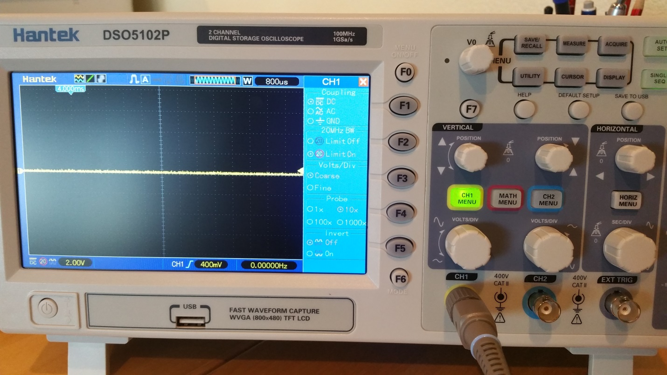

1. Next, move the reference point (GND) of the waveform by adjusting the CH1 “Position” knob in the “Vertical Control” group. The location of the waveform’s reference point is indicated by a small triangle to the left of the display with the channel number inside of the triangle (see “18” in Figure 2).
   1. Note that the color of the waveform (e.g. yellow) matches the color of the channel button. Any setting associated with a particular channel will have its color matched with the waveform.
   2. Place the vertical reference point for CH1 to the center of the vertical axis by pressing CH1’s “Position” knob.
2. Configure the vertical axis by adjusting the “VOLTS/DIV” knob in the vertical control group.
   1. Note that the value in sub-window 14 (refer to Figure 2) changes as the “VOLTS/DIV” knob is adjusted.
   2. The value read here corresponds to the number of volts per major divisions on the screen. So, for example, for a setting of 2.00VOLTS/DIV, the entire screen can display a signal that has an amplitude of 16V (for the 8 total major divisions on the screen).
3. Construct a simple LED circuit with a current limiting resistor that allows a maximum of 6mA of current through the LED when connected to a 9V battery. Assume the forward voltage of the LED is .

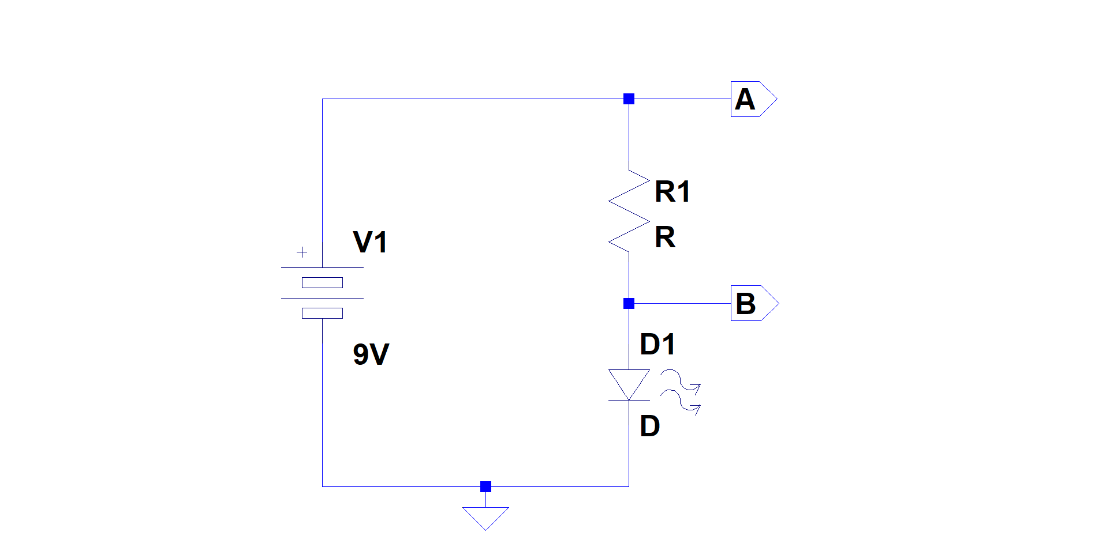

1. Connect your probe’s ground clip to GND (negative terminal of the battery).
2. Connect your probe to node A. Record the voltage measurement below  
     
    ___________________
3. Connect your probe to node B. Record the voltage measurement below  
     
    ___________________
4. Based on the measurements above, what is the current through R1?   
     
    ___________________

Testing the Probe and Time Settings

Oscilloscopes normally provide a simple “Probe Compensation Terminal” (see Figure 1) which provides a test signal. For today’s project, we will use this terminal to simply display a “time varying” signal on the probe.

The “Compensation Terminal” outputs a square wave with an amplitude of ~5V and a frequency of 1KHz. Once properly configured and connected, you should see a 1 KHz square wave on the Readout Display.

1. Make sure the vertical configuration is set to 2.00V/Div.
2. Set the horizontal axis by adjusting the “SEC/DIV” knob in the “Horizontal Control” group.
   1. The time per major division setting on the horizontal axis is displayed in window 8 (see Figure 2).
   2. Set the time per division to 400s.
3. Connect the ground clip of the probe to the ground terminal of the “Compensation Terminal”. Be very careful not to connect the ground clip of the probe to the “signal terminal”; this can damage the oscilloscope.
4. Connect the probe tip to the signal terminal of the Compensation terminal. You should see a waveform similar to the one below on your Readout Display.

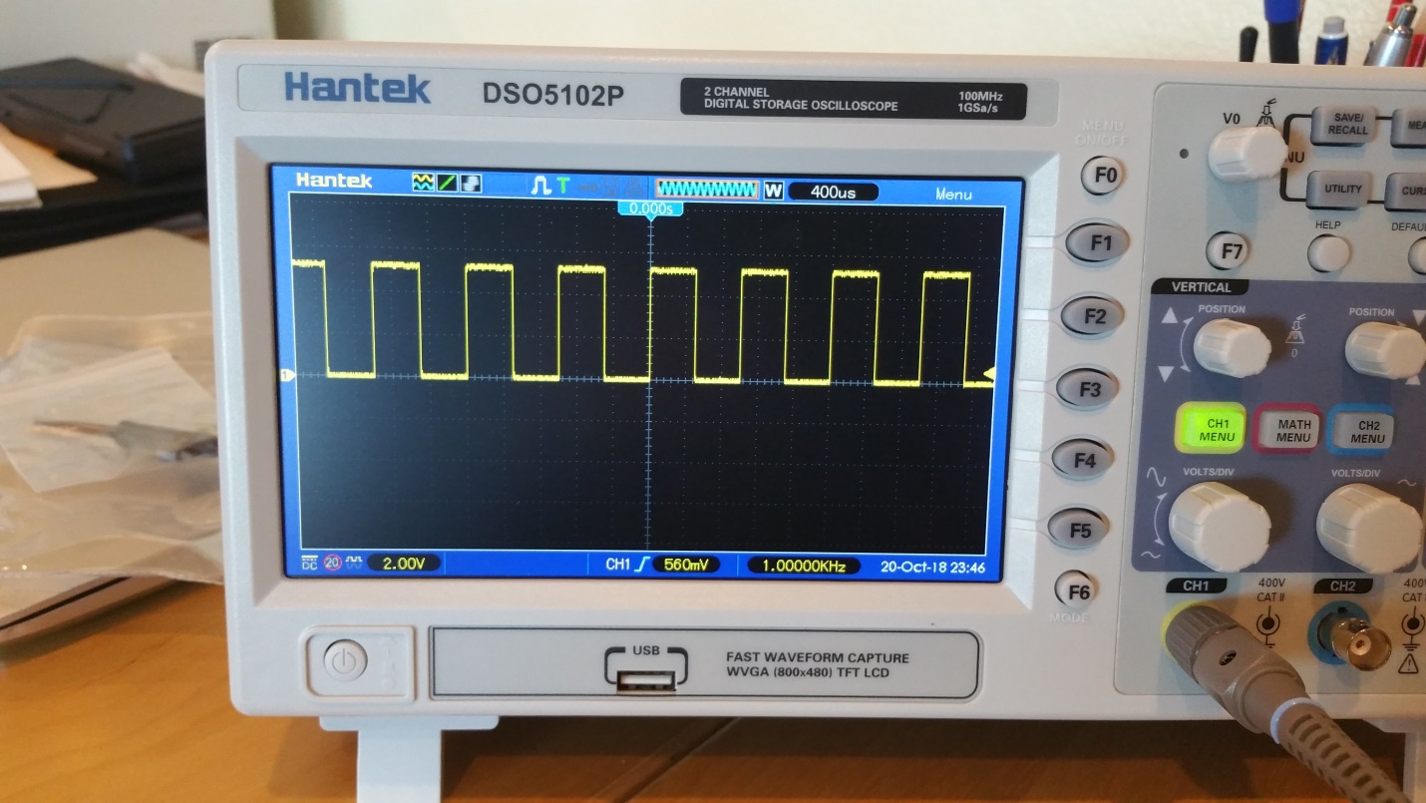

1. Adjust the horizontal trigger position by turning the “Position” knob in the “Horizontal Control”.
   1. Observe how the waveform “moves” as the “Position” knob is adjusted.
   2. Place the horizontal trigger position back at the center of the horizontal axis by pressing the “Position” knob.
2. Determine the signal’s amplitude from the displayed waveform and record it below.  
     
    ___________________
3. Determine the signal’s period from the displayed waveform and record it below.  
     
    ______________________
4. Determine the frequency from the measured period above and record it below  
     
    ______________________
5. Press the “MEASURE” button in the “Function Button” group.
   1. On the right hand side of the Readout Display, you can see various measurements for the signal
   2. Read and record frequency, period and peak to peak (Pk-Pk) amplitude below  
        
       ___________________  
        
       ___________________  
        
       _______________
   3. How do these values compare to the ones you measured in steps 6-7? How are they different and why?

## Function Generators

### Discussion Overview

Function generators are used in electrical engineering to create a certain periodic signal that can be used to “excite” a circuit in order to observe and test the behavior of the circuit. One example of such circuits is an amplifier where the input signal (such as an audio signal) is amplified to make it louder. Another example is a filter, where certain frequency components of an input signal is filtered out. To test out such circuits, a simple sinusoidal input signal, for example, can be used to test out the correct performance of the circuit.

Most signal generators are capable of outputting sinusoidal, square and triangular waves. One can set the amplitude and frequency of these signals based on what is needed to test the circuit.

In the following subsections, we will go through step by step procedures on how to properly configure the integrated waveform generator in our oscilloscopes to generate various common waveforms.

### Procedures

Once again, for all the steps below, refer to Figure 1 for the location of configuration knobs, buttons or soft-keys and Figure 2 for the indicators on the Readout Display.

Basic Setup

1. Connect the BNC cable included with your oscilloscope to the “GEN AMP” connector (“Power Amplifier Output Channel” in Figure 1) on the scope.
2. Turn on the waveform generator by pressing the “GEN ON” button (“Power Amplifier Button” in Figure 1).
3. Press “F1” button (in the “Menu Button” group in Figure 1) to select “Sine”. This will configure the waveform generator to output a sinusoidal signal.
4. Using the buttons in the “Menu Button” group corresponding to the following settings,
   1. Frequency: Set the wave frequency of the signal to 10KHz.
   2. Amplitude: Set the wave amplitude to 3V peak to peak
   3. Y Offset: Make sure the Y offset is set to 0V
   4. Output: Make sure the output type is set to continuous
   5. Ext Trig: Make sure the external trigger is turned off
5. Configure the vertical settings for “CH1” on the scope:
   1. Set “VOLT/DIV” to 1.00V
   2. Make sure GND (or zero volt) is centered on the vertical axis by pressing the “POSITION” knob
6. Configure the horizontal setting:
   1. Set “SEC/DIV” (in the “Horizontal Control” group in Figure 1) to 200s.
   2. Make sure the horizontal trigger point is centered on the horizontal axis by pressing the “HORIZ” knob (in the “Horizontal Control” group in Figure 1).
7. Connect the other end of the BNC cable to the BNC connector for “CH1” (in the “Input Channel for Analog Signal” Figure 1)
8. Determine the signal’s amplitude from the displayed waveform and record it below.  
     
    ___________________
9. Determine the signal’s period from the displayed waveform and record it below.  
     
    ______________________
10. Determine the frequency from the measured period above and record it below  
      
     ______________________
11. Press the “MEASURE” button in the “Function Button” group.
    1. On the right hand side of the Readout Display, you can see various measurements for the signal
    2. Read and record frequency, period and peak to peak (Pk-Pk) amplitude below  
         
        ___________________  
         
        ___________________  
         
        _______________

Testing a Simple Circuit

1. Construct a simple LED circuit with a current limiting resistor that allows a maximum of 6mA of current through the LED when connected to a 5V source. Assume the forward voltage of the LED is .

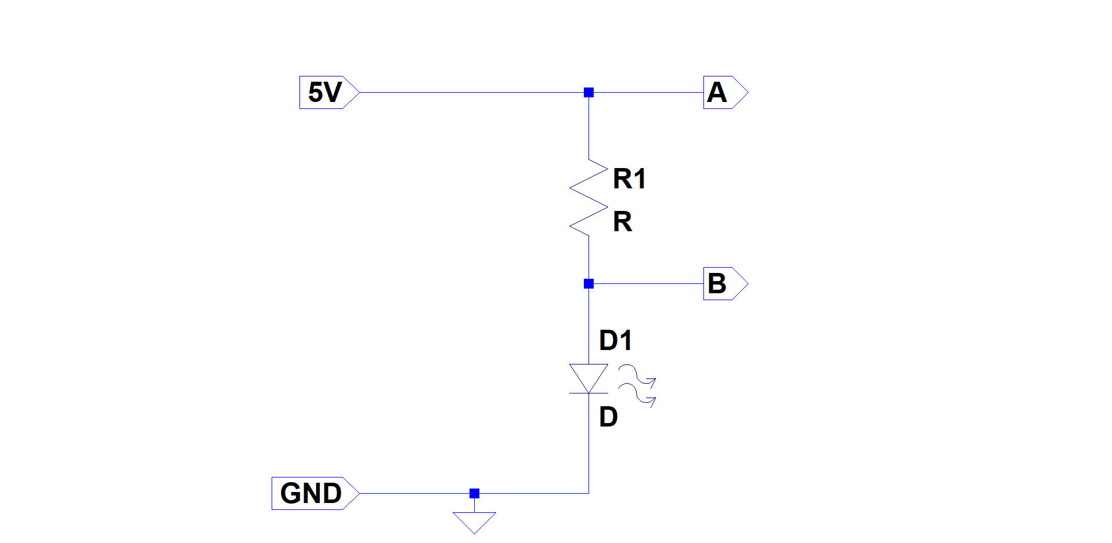

1. Disconnect the BNC cable from “CH1” and “GEN AMP”.
2. Connect the BNC to Hook Clip Test Probe cable to “GEN AMP”.
3. Set the waveform generator to output a square wave signal
   1. Press the “GEN ON” button until the waveform selection soft menu is displayed on the right hand side of the screen.
   2. Press the “F2” button (in the “Menu Button” group in Figure 1) to select “Square”.
   3. Frequency: Set the wave frequency of the signal to 1Hz.
   4. Amplitude: Set the wave amplitude to 5V peak to peak
   5. Y Offset: Set the Y offset to 2.5V
   6. Output: Make sure the output type is set to continuous
   7. Ext Trig: Make sure the external trigger is turned off
4. Connect the BNC connector of the oscilloscope’s probe to the BNC connector for “CH1” on the scope.
   1. Set the “VOLTS/DIV” in the “Vertical Control” group to 1.00V
   2. Make sure the vertical reference point (GND) is centered by pressing the “POSITION” knob for “CH 1”.
   3. Set the horizontal “SEC/DIV” to 200ms.
   4. Make sure the horizontal reference point is centered by pressing the “HORIZ” knob.
5. Connect the black (GND) hook clip from the waveform generator to the GND node in your circuit.
6. Connect the red (signal) hook clip form the waveform generator to the 5V node in your circuit.
7. What is your circuit doing?  
     
     
     
   How long do you think the LED is staying on each time?  
     
     
     
   How long do you think the LED is staying off each time?
8. Connect your Scope probe’s ground clip to GND node of your circuit.
9. Connect your probe to node A.
   1. Determine the signal’s amplitude from the displayed waveform and record it below.  
        
       ___________________
   2. Determine the signal’s period from the displayed waveform and record it below.  
        
       ______________________
   3. Determine the frequency from the measured period above and record it below  
        
       ______________________
10. Connect the second scope probe to “CH2” BNC connector on the scope.
    1. Turn on “CH 2” by pressing the “CH 2” button in the “Vertical Control” group.
    2. Set the “VOLTS/DIV” in the “Vertical Control” group to 1.00V by adjusting the “VOLTS/DIV” knob for “CH 2”.
    3. Make sure the vertical reference point (GND) is centered by pressing the “POSITION” knob for “CH 2”.
    4. Note that the horizontal configuration is the same for both CH1 and CH2 (200ms/div).
11. Connect the ground clip for CH 2’s probe to GND node of your circuit.
12. Connect CH 2’s probe to node B in your circuit.
    1. Determine the signal’s amplitude from the displayed waveform and record it below.  
         
        ___________________
    2. Determine the signal’s period from the displayed waveform and record it below.  
         
        ______________________
    3. Determine the frequency from the measured period above and record it below  
         
        ______________________
13. Is the amplitude measure for node B what you had expected? How about the period and frequency?